
JAVA PROGRAMMING

Practice Program Unit 4

Submitted by:
Faustena S
(2548313)
2 MDS A

Faculty:
Dr. Heamenth K S

Submitted on 06 Feb. 26

Department of Computer Science and Statistics
Christ (Deemed To Be University),
Yeswanthpur, Bangalore

Defining Classes and Objects 1. Student class with one object class Student { String name; int age;
String course;
}

public class lab2 { public static void main(String[] args) { Student s1 = new Student(); s1.name = "Tina "; s1.age = 20; s1.course = "Data Science";

System.out.println("Name: " + s1.name);
System.out.println("Age: " + s1.age);
System.out.println("Course: " + s1.course);
}
}
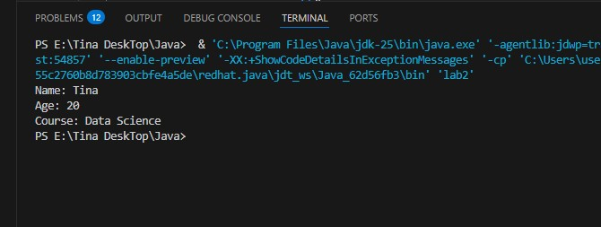
2. Two student objects with method class Student {
String name;
String course;
}

class PostgraduateStudent extends Student {
String specialization;

void display() {
System.out.println("Name: " + name);
System.out.println("Course: " + course);
System.out.println("Specialization: " + specialization);
}
}

public class p2 { public static void main(String[] args) {
PostgraduateStudent pg = new PostgraduateStudent();
pg.name = "Tina"; pg.course = "MDS"; pg.specialization = "AI/ML";

pg.display();
}
}
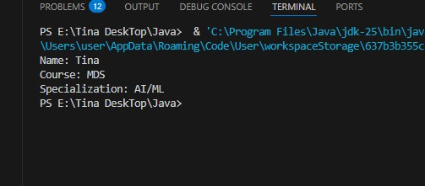
3. Department class with students class Student1 { String name; int age;
String course;

void displayAdmission() {
System.out.println("Name: " + name);
System.out.println("Age: " + age);
System.out.println("Course: " + course);
System.out.println();
}
}

public class p3 { public static void main(String[] args) { Student1 s1 = new Student1(); s1.name = "Tina"; s1.age = 19; s1.course = "Data Science";

Student1 s2 = new Student1(); s2.name = "Sruthi"; s2.age = 21; s2.course = "Maths";

s1.displayAdmission(); s2.displayAdmission();
}
}
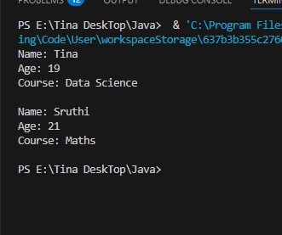
4. Age eligibility check
class Student { String name; int age;

void checkEligibility() { System.out.println("Name: " + name); if(age >= 18) {
System.out.println("Eligible for admission");
} else {
System.out.println("Not eligible");
}
System.out.println();
}
}

public class Test { public static void main(String[] args) { Student s1 = new Student(); s1.name = "Tom"; s1.age = 17;

Student s2 = new Student(); s2.name = "Jerry"; s2.age = 19;

s1.checkEligibility(); s2.checkEligibility(); }
}
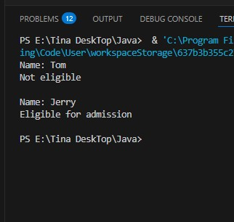

5. Array of students class Student4 { String name; int age; boolean admitted;

void display() {
System.out.println("Name: " + name + ", Age: " + age);
}
}

public class p6 { public static void main(String[] args) {
Student4[] students = new Student4[3];

students[0] = new Student4(); students[0].name = "tina"; students[0].age = 20; students[0].admitted = true;

students[1] = new Student4(); students[1].name = "bolu"; students[1].age = 19; students[1].admitted = false;

students[2] = new Student4(); students[2].name = "dolu"; students[2].age = 21; students[2].admitted = true;

System.out.println("Admitted Students:"); for(int i = 0; i < students.length; i++) { if(students[i].admitted) { students[i].display();
}
}
}
}

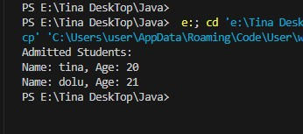
Constructors and Methods 1. Constructor with name and course class Student5 { String name;
String course;

Student5(String n, String c) { name = n; course = c;
}

void display() {
System.out.println("Name: " + name);
System.out.println("Course: " + course);
}
}

public class p7 { public static void main(String[] args) { Student5 s1 = new Student5("Jo jo", "CSE"); s1.display();
}
}
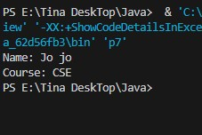
2. Auto-generate student ID class Student6 { String name; int studentId; static int counter = 1000;

Student6(String n) { name = n; studentId = ++counter;
}

void display() {
System.out.println("ID: " + studentId + ", Name: " + name);
}
}

public class p9 { public static void main(String[] args) { Student6 s1 = new Student6("tina");
Student6 s2 = new Student6("terasia");
Student6 s3 = new Student6("Carlin");

s1.display(); s2.display(); s3.display();
}
}
3. Overloaded constructors class Student {
String name; String course; boolean hostel;

Student(String n, String c) { name = n; course = c; hostel = false;
}

Student(String n, String c, boolean h) { name = n; course = c; hostel = h;
}

void display() {
System.out.println("Name: " + name);
System.out.println("Course: " + course); System.out.println("Hostel: " + hostel);
System.out.println();
}
}

public class Test { public static void main(String[] args) {
Student s1 = new Student("John", "CSE");
Student s2 = new Student("Mary", "ECE", true);

s1.display(); s2.display();
}
}
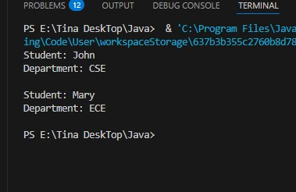

class Student7 { String name; String course; boolean hostel;

Student7(String n, String c) { name = n; course = c; hostel = false;
}

Student7(String n, String c, boolean h) { name = n; course = c; hostel = h;
}

void display() {
System.out.println("Name: " + name);
System.out.println("Course: " + course);
System.out.println("Hostel: " + hostel);
System.out.println();
}
}

public class p10 { public static void main(String[] args) { Student7 s1 = new Student7("tina", "CSE");
Student7 s2 = new Student7("Money", "ECE", true);

s1.display(); s2.display();
}
}

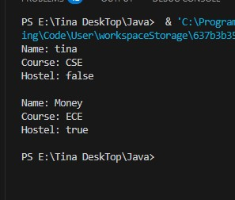

4. Methods to display and update class Student8 { String name;
String course;

Student8(String n, String c) { name = n; course = c;
}

void displayDetails() {
System.out.println("Name: " + name + ", Course: " + course);
}

void updateCourse(String newCourse) { course = newCourse;
System.out.println("Course updated to: " + course);
}
}

public class p11 { public static void main(String[] args) {
Student8 s1 = new Student8("Tom", "Mathematics"); s1.displayDetails(); s1.updateCourse("Physics"); s1.displayDetails();
}
}
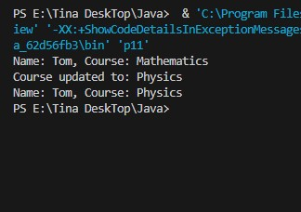
5. Constructor then method call
class Student9 { String name; int age;

void display() {
System.out.println("Name: " + name);
System.out.println("Age: " + age);
}
}

class UndergraduateStudent extends Student9 {
String program;

void showProgram() {
System.out.println("Program: " + program);
}
}

public class p12 { public static void main(String[] args) {
UndergraduateStudent ug = new UndergraduateStudent(); ug.name = "Tina"; ug.age = 20; ug.program = "B.Tech";

ug.display(); ug.showProgram(); }
}
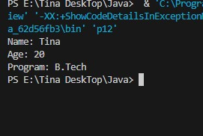
Inheritance
1. Base and derived class class Student {
String name;
int age;

void display() {
System.out.println("Name: " + name);
System.out.println("Age: " + age);
}
}

class UndergraduateStudent extends Student {
String program;

void showProgram() {
System.out.println("Program: " + program);
}
}

public class Test {
public static void main(String[] args) {
UndergraduateStudent ug = new UndergraduateStudent();
ug.name = "Tina";
ug.age = 20;
ug.program = "MDS";

ug.display();
ug.showProgram();
}
}
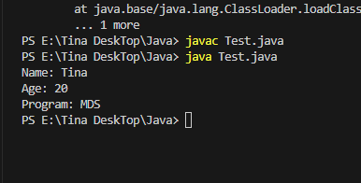
2. PostgraduateStudent with specialization
class Student {
String name;
String course;
}

class PostgraduateStudent extends Student {
String specialization;

void display() {
System.out.println("Name: " + name);
System.out.println("Course: " + course);
System.out.println("Specialization: " + specialization);
}
}

public class Test {
public static void main(String[] args) {
PostgraduateStudent pg = new PostgraduateStudent();
pg.name = "Tina";
pg.course = "MDS";
pg.specialization = "Data Science";

pg.display();
}
}
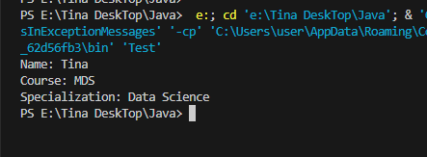
3. InternationalStudent with passport class Student {
String name;
String course;
}

class InternationalStudent extends Student {
String passportNo;
String country;

void display() {
System.out.println("Name: " + name);
System.out.println("Course: " + course);
System.out.println("Passport: " + passportNo);
System.out.println("Country: " + country);
}
}

public class Test { public static void main(String[] args) {
InternationalStudent is = new InternationalStudent(); is.name = "John"; is.course = "CSE"; is.passportNo = "P123456"; is.country = "USA";

is.display();
}
}
4. Super keyword demo class Student {
String name;

Student(String n) { name = n;
System.out.println("Parent constructor");
}
}

class UndergraduateStudent extends Student {
String program;

UndergraduateStudent(String n, String p) {
super(n); program = p;
System.out.println("Child constructor");
}

void display() {
System.out.println("Name: " + name + ", Program: " + program);
}
}

public class Test { public static void main(String[] args) {
UndergraduateStudent ug = new UndergraduateStudent("Alice", "B.Tech");
ug.display();
}
}
5. Code reuse using inheritance class Student { String name; int rollNo;

void setBasicDetails(String n, int r) { name = n; rollNo = r;
}

void displayBasic() {
System.out.println("Name: " + name);
System.out.println("Roll No: " + rollNo);
}
}

class UndergraduateStudent extends Student {
String branch;

void setBranch(String b) { branch = b;
}

void displayAll() { displayBasic();
System.out.println("Branch: " + branch);
}
}

public class Test { public static void main(String[] args) {
UndergraduateStudent ug = new UndergraduateStudent(); ug.setBasicDetails("Tom", 101); ug.setBranch("CSE"); ug.displayAll();
}
}
Method Overriding
1. Student class with calculateFee class Student {
String name;

int calculateFee() { return 10000;
}
}

public class Test { public static void main(String[] args) {
Student s = new Student();
System.out.println("Fee: " + s.calculateFee());
}
}
2. Override in UndergraduateStudent class Student { int calculateFee() { return 10000;
}
}

class UndergraduateStudent extends Student { int calculateFee() { return 15000;
}
}

public class Test { public static void main(String[] args) {
UndergraduateStudent ug = new UndergraduateStudent();
System.out.println("UG Fee: " + ug.calculateFee());
}
}
3. Override in PostgraduateStudent class Student { int calculateFee() { return 10000;
}
}

class PostgraduateStudent extends Student { int calculateFee() { return 20000;
}
}

public class Test { public static void main(String[] args) {
PostgraduateStudent pg = new PostgraduateStudent();
System.out.println("PG Fee: " + pg.calculateFee());
}
}
4. Parent reference
class Student { int calculateFee() { return 10000;
}
}

class UndergraduateStudent extends Student { int calculateFee() { return 15000;
}
}

public class Test { public static void main(String[] args) {
Student s = new UndergraduateStudent();
System.out.println("Fee: " + s.calculateFee());
}
}
5. Runtime behavior class Student { int calculateFee() { return 10000;
}
}

class UndergraduateStudent extends Student { int calculateFee() {
return 15000;
}
}

class PostgraduateStudent extends Student { int calculateFee() { return 20000;
}
}

public class Test { public static void main(String[] args) {
Student s1 = new UndergraduateStudent();
Student s2 = new PostgraduateStudent();

System.out.println("UG Fee: " + s1.calculateFee());
System.out.println("PG Fee: " + s2.calculateFee());
}
}
Polymorphism 1. Method overloading class Admission { void admitStudent(String name) {
System.out.println("Admitted: " + name);
}

void admitStudent(String name, String course) { System.out.println("Admitted: " + name + " in " + course);
}

void admitStudent(String name, String course, int year) {
System.out.println("Admitted: " + name + " in " + course + " year " + year);
}
}

public class Test { public static void main(String[] args) { Admission a = new Admission();
a.admitStudent("John");
a.admitStudent("Mary", "CSE");
a.admitStudent("Tom", "ECE", 2);
}
}
2. Overload calculateFee class Student { int calculateFee(String course) { return 10000;
}

int calculateFee(String course, boolean hostel) {
if(hostel) return 15000; return 10000;

int calculateFee(String course, boolean hostel, boolean transport) { int fee = 10000; if(hostel) fee += 5000; if(transport) fee += 2000; return fee;
}
}

public class Test { public static void main(String[] args) {
Student s = new Student();
System.out.println("Basic: " + s.calculateFee("CSE"));
System.out.println("With hostel: " + s.calculateFee("CSE", true));
System.out.println("Full: " + s.calculateFee("CSE", true, true));
}
}
3. Runtime polymorphism
class Student { void display() {
System.out.println("Student");
}
}

class UndergraduateStudent extends Student { void display() {
System.out.println("Undergraduate Student");
}
}

class PostgraduateStudent extends Student { void display() {
System.out.println("Postgraduate Student");
}
}

public class Test { public static void main(String[] args) {
Student s1 = new UndergraduateStudent();
Student s2 = new PostgraduateStudent();

s1.display(); s2.display();
}
}
4. Dynamic method dispatch class Student { int calculateFee() { return 10000;
}
}

class UndergraduateStudent extends Student { int calculateFee() {
return 15000;
}
}

class PostgraduateStudent extends Student { int calculateFee() { return 20000;
}
}

public class Test { static void processFee(Student s) {
System.out.println("Fee: " + s.calculateFee());
}

public static void main(String[] args) { processFee(new UndergraduateStudent()); processFee(new PostgraduateStudent());
}
}
5. Array of Student references class Student { String name; int calculateFee() { return 10000;
}
}

class UndergraduateStudent extends Student { int calculateFee() { return 15000;
}
}

class PostgraduateStudent extends Student { int calculateFee() { return 20000;
}
}

public class Test { public static void main(String[] args) {
Student[] students = new Student[3];

students[0] = new Student(); students[1] = new UndergraduateStudent(); students[2] = new PostgraduateStudent();

for(int i = 0; i < students.length; i++) {
System.out.println("Fee: " + students[i].calculateFee());
}
}
}
Encapsulation and Abstraction
1. Getters and setters class Student { private String name; private int age;

public void setName(String n) { name = n;
}

public String getName() { return name;
}

public void setAge(int a) { age = a;
}

public int getAge() { return age;
}
}

public class Test { public static void main(String[] args) { Student s = new Student();
s.setName("John");
s.setAge(20);

System.out.println("Name: " + s.getName());
System.out.println("Age: " + s.getAge());
}
2. Restrict admission number class Student { private int admissionNo; private String name;

public Student(int admNo, String n) { admissionNo = admNo; name = n;
}

public int getAdmissionNo() { return admissionNo;
}

public void display() {
System.out.println("Admission No: " + admissionNo);
System.out.println("Name: " + name);
}
}

public class Test { public static void main(String[] args) { Student s = new Student(101, "Alice");
s.display();
System.out.println("Admission: " + s.getAdmissionNo());
}
3. Validate age class Student { private String name; private int age;

public void setAge(int a) { if(a >= 18 && a <= 25) {
age = a;
System.out.println("Age set successfully");
} else {
System.out.println("Invalid age");
}
}

public int getAge() { return age;
}
}

public class Test { public static void main(String[] args) {
Student s = new Student();
s.setAge(17);
s.setAge(20);
System.out.println("Age: " + s.getAge());
}
4. Abstract class abstract class StudentAdmission {
String name;

abstract int calculateFee();

void display() {
System.out.println("Name: " + name);
System.out.println("Fee: " + calculateFee());
}
}

class UndergraduateStudent extends StudentAdmission { int calculateFee() { return 15000;
}
}

class PostgraduateStudent extends StudentAdmission { int calculateFee() { return 20000;
}

}

public class Test { public static void main(String[] args) {
StudentAdmission s1 = new UndergraduateStudent(); s1.name = "John"; s1.display();

StudentAdmission s2 = new PostgraduateStudent(); s2.name = "Mary"; s2.display();
}
}
5. Interface implementation interface ScholarshipEligible { boolean checkEligibility();
}

class Student implements ScholarshipEligible { String name; float marks;

public boolean checkEligibility() { return marks >= 85.0;
}

void display() {
System.out.println("Name: " + name);
System.out.println("Eligible: " + checkEligibility());
}
}

public class Test { public static void main(String[] args) { Student s = new Student();
s.name = "Alice";
s.marks = 90.5f;
s.display();
}
}
Packages
1. Package university.admission File: university/admission/Admission.java package university.admission;

public class Admission { public void admitStudent(String name) {
System.out.println("Admitted: " + name);
}
}
File: Test.java import university.admission.Admission;

public class Test {
public static void main(String[] args) { Admission a = new Admission();
a.admitStudent("John");
}
}
2. Package university.students File: university/students/Student.java package university.students;

public class Student { public String name; public int rollNo;

public void display() {
System.out.println("Name: " + name + ", Roll: " + rollNo);
}
} File: Test.java import university.students.Student;

public class Test { public static void main(String[] args) { Student s = new Student();
s.name = "Alice";
s.rollNo = 101;
s.display();
}
}
3. Access from another package File: university/students/Student.java package university.students;

public class Student { public String name;

public void display() {
System.out.println("Student: " + name);
}
}
File: university/admission/Admission.java package university.admission;

import university.students.Student;

public class Admission { public void processAdmission() { Student s = new Student();
s.name = "Bob";
s.display();
}
}
4. Protected access File: university/students/Student.java package university.students;

public class Student { protected String name;

protected void showName() {
System.out.println("Name: " + name);
}
}
File: university/admission/UGStudent.java package university.admission;

import university.students.Student;

public class UGStudent extends Student { public void display() { name = "Charlie"; showName();
}
}
5. Mini university system File: university/students/Student.java package university.students;

public class Student { public String name; public int rollNo;
}
File: university/admission/Admission.java package university.admission;

import university.students.Student;

public class Admission { public Student admitStudent(String name, int roll) { Student s = new Student();
s.name = name;
s.rollNo = roll; return s;
}
}
File: university/fees/FeeCalculator.java package university.fees;

import university.students.Student;

public class FeeCalculator { public int calculateFee(Student s) { return 15000;
}
} File: Test.java import university.students.Student; import university.admission.Admission; import university.fees.FeeCalculator; public class Test { public static void main(String[] args) { Admission adm = new Admission();
Student s = adm.admitStudent("John", 101);

FeeCalculator fc = new FeeCalculator(); int fee = fc.calculateFee(s);

System.out.println("Student: " + s.name);
System.out.println("Roll: " + s.rollNo);
System.out.println("Fee: " + fee);
}
}

